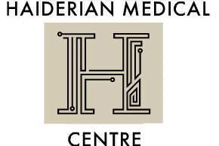
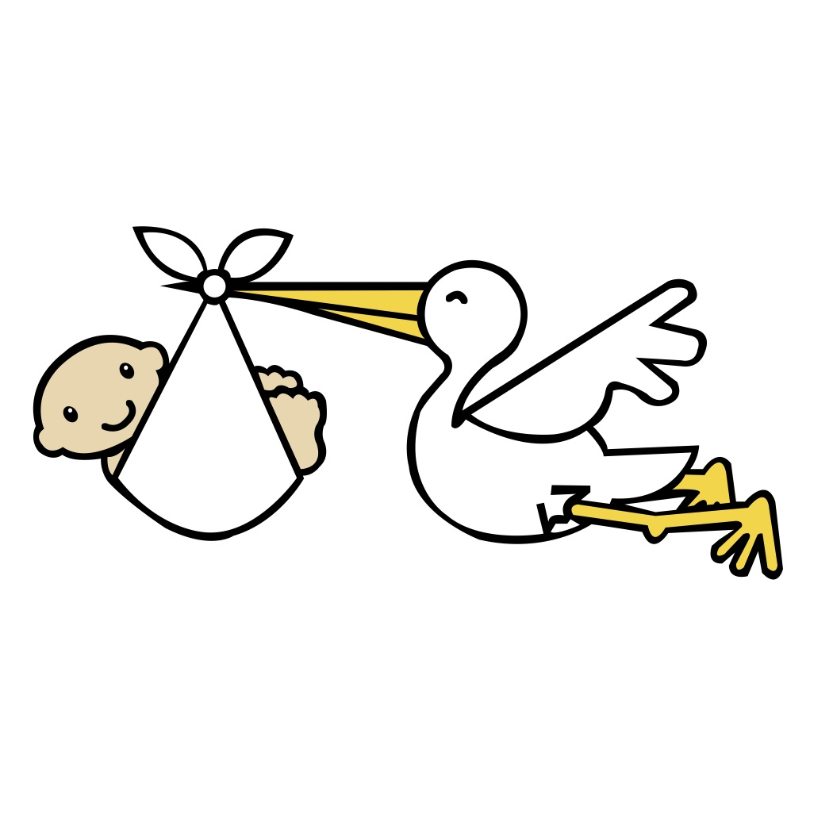

YOU’RE PREGNANT…

Things to do first

- Start folic acid (400mcg) and vitamin D (10mcg) supplement a day, if you haven’t already (if your BMI is >30 you are will need 5mg folic acid daily)
- Think about caffeine intake (limit to 200mg a day = 2 cups of instant coffee)
- Consider your alcohol intake. No agreed safe limit - Department of Health advises avoid completely. Royal College Obstetricians says not at all in first trimester and afterwards no more than 1-2units, once or twice a week
- Know about which foods to avoid (see NHS choices website for details)
- If you are a smoker, please have a chat with us about help cutting down
- It’s never too early to start doing pelvic floor exercises!

What happens now?

The exact timeline depend on which hospital you have decided to go to for your antenatal care and delivery. Most of our patients go to Queen’s Hospital or other hospitals in the Braking Havering and Redbridge area.
Once your GP has referred you to the hospital of your choice, the antenatal team will contact you, usually by letter, for your first meeting with the midwife.
This is the ‘booking appointment’, around 8-12 weeks, as calculated from your last period.
A blood sample will be taken at this time for several tests, including blood group, HIV, hepatitis and rubella immunity.
The first (dating) scan will be between 8-14 weeks may be at the same time as the booking appointment, or within a few weeks. This scan gives a more accurate dating of the pregnancy, which replaces the calculation from your last period.
There is an antenatal appointment with a midwife at 16 weeks to see how things are going and review the bloods from your booking.
The second (anomaly) scan is at 20 weeks. This checks the baby is growing properly and it is sometimes possible to tell the sex (be aware some hospitals do charge for this as it is not seen to be part of essential care).
Antenatal appointments then follow at 25, 28, 31, 34, 36, 38 and 40 weeks (term) and 41 weeks if you’re still pregnant!
These appointments will be with the midwife and/or obstetrician. You will be given a more detailed list by your midwife on your first visit.
Please arrive for your appointment a few minutes early to produce a urine sample for testing. Sample bottles can be picked up from reception.

- In special cases, pregnancies may need closer monitoring with more appointments and scans; the above gives a general overview of a straightforward pregnancy.
- Some women will also have a glucose test at 28 weeks to check for diabetes in pregnancy.

Vaccines

- Whooping cough vaccine after 16 weeks (book at the surgery) so you can pass immunity onto your baby to avoid this potentially fatal disease when they are very young
- Flu Vaccine free to all pregnant women during the flu season (Sept- Feb)

Paperwork

- Maternity Exemption Certificate for free prescriptions: You are entitled to free prescriptions and dental care whilst pregnant and for a year after having a baby – your doctor or midwife can sign a form (in this pack) so you can apply for your card.
- Mat B1 form for Maternity Pay: Your employer will need this form in order to issue your maternity pay. It can only be completed 20 WEEKS BEFORE YOUR EXPECTED DUE DATE, by a doctor or midwife who has seen you. It is not possible to do these earlier than this, or if you haven’t been seen by the doctor / midwife signing the form.

Useful websites

- www.nhs.uk NHS Choices – search under ‘pregnancy’. Lots of info on foods, exercise, common problems, tests and scans, conditions in pregnancy, labour, babies and beyond
- www.patient.co.uk – search ‘planning to become pregnant’. Good section on foods.
- www.babycentre.co.uk ‘complete online resource for new and expectant parents’
- www.emmasdiary.co.uk ‘baby and pregnancy advice for mums-to-be’
- www.nct.org.uk National Childbirth Trust – charity offering support and information …not just for the groups! There’s a good page on pelvic floor exercises
- www.rcog.org.uk Royal College Obstetricians and Gynaecologists. Search for patient information. Up to date advice based on recent evidence and guidelines
- www.breastfeedingnetweork.org.uk - good advice, plus a breastfeeding helpline / live chat
IMPORTANT

It is common to get mild ‘period-pain’ like cramps early on in pregnancy (paracetamol is safe to take) but if you have stronger pains or bleeding, please speak to a GP.

If bleeding is very heavy or pain is severe, it is appropriate to go to A&E.

In some cases, an early scan is indicated – your GP can arrange this at a local hospital, if appropriate.

